EMBARGOED UNTIL: 0001 Monday 3 April 2023

Oxford University Museum of Natural History purchases archive material belonging to pioneering geologist William Buckland and his wife Mary (née Morland)

Oxford University Museum of Natural History (OUMNH) has acquired an important archival collection relating to pioneering 19th-century geologist and theologian William Buckland. Passed by descent to the current owners, the archive contains over 1,000 items including letters, notebooks, family papers, prints, and artworks.

The acquisition has been made possible with support from the National Heritage Memorial Fund, Arts Council England/V&A Purchase Grant Fund, Friends of the National Libraries, Headley Trust, and other private donors.

Buckland was a hugely influential figure in academia, politics, science, and religion. He successively held the positions of Reader in Mineralogy and Geology at Oxford University; Canon of Christ Church, Oxford; and Dean of Westminster. He was the first to name and describe a fossil dinosaur (Megalosaurus), and his research into an ancient hyaena den laid the foundations of the science we would now call palaeoecology. Buckland was also a notable convert to glacial theory, and showed how glaciation rather than a global flood shaped the British landscape.

Head of Earth Collections Eliza Howlett said:

“The Museum’s acquisition of a large collection of Buckland papers from private hands is a game-changer for historians of science and others with an interest in the histories of gender, class, and colonialism. Combined with the already large and diverse Oxford collections, the new materials will confirm OUMNH as the epicentre for future research, and we are tremendously grateful to the many trusts and foundations, and to the private individuals, who generously contributed to this purchase.”

The archive reveals aspects of Buckland’s life as a student at Christ Church, as well his work as a practising geologist, university lecturer, and eminent churchman. Evidence from the archive provides detailed insight into the thinking and institutions of the early 19th century, a time when science and theology often gave different explanations for natural phenomena. Numerous letters on topics ranging from zoology and geology to aesthetics and administration demonstrate the diverse network of people connected with Buckland. They include correspondence with major figures such as art critic John Ruskin and prime minister Robert Peel.

The archive also includes original artworks, such as Thomas Sopwith’s watercolour of William Buckland (previously thought to be a portrait of Mary Anning), and a rare, coloured version of the lithograph based on Henry de la Beche’s drawing Duria Antiquior – the first pictorial representation of a scene of prehistoric life based on fossil evidence. Excitingly, Buckland’s wife Mary (née Morland), a respected naturalist and illustrator, is well represented, with highlights including two of her sketchbooks. One of these, dating from before her marriage to Buckland, contains exquisite ink and watercolour drawings of natural history specimens, and highlights the huge artistic and scientific contribution she made to her husband’s work.

Dr Simon Thurley CBE, Chair of the National Heritage Memorial Fund, said:

“I am delighted the National Heritage Memorial Fund is able to support Oxford University Museum of Natural History to acquire the outstanding Buckland Archive and ensure that the collection remains together and is saved for the nation.

“It is fantastic news that this collection can be shared with the public, providing an insight into the scientific thinking and institutions of early 19th-century England, as well as providing a rich and colourful primary account of Buckland’s life and career. It is also wonderful to see that the significant artistic and scientific contributions made by Buckland’s wife Mary (née Morland) are highlighted through this collection, as well as the important roles of other ‘invisible technicians’ such as quarrymen, collectors, preparators and replicators, presenting a fuller picture of those involved in natural science at that time.”

OUMNH is already the pre-eminent repository for Buckland’s archive and object collections, with existing holdings including extensive professional correspondence, lecture notes, and teaching diagrams, as well as more than 4,000 fossil, rock, and mineral specimens. The additional archive fits beautifully with the Museum’s existing Buckland material, providing missing pieces of the jigsaw. Reuniting these collections both physically and digitally will allow researchers and other museum audiences access to the full spectrum of Buckland material, and adds significantly to our understanding of his life and work.

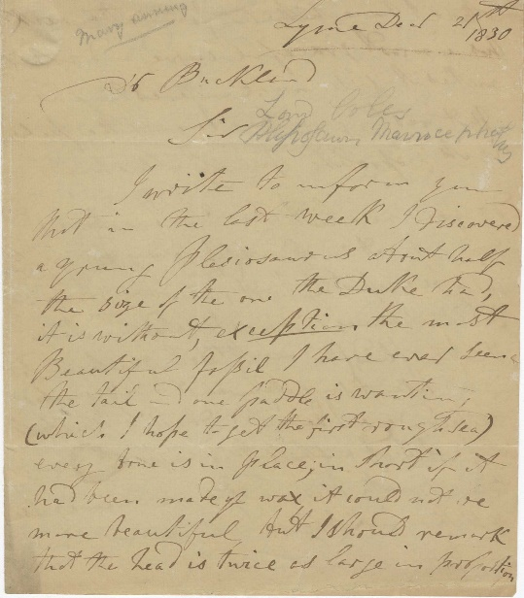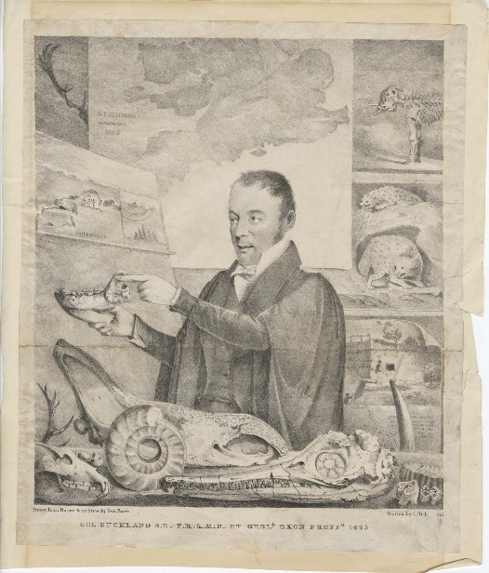
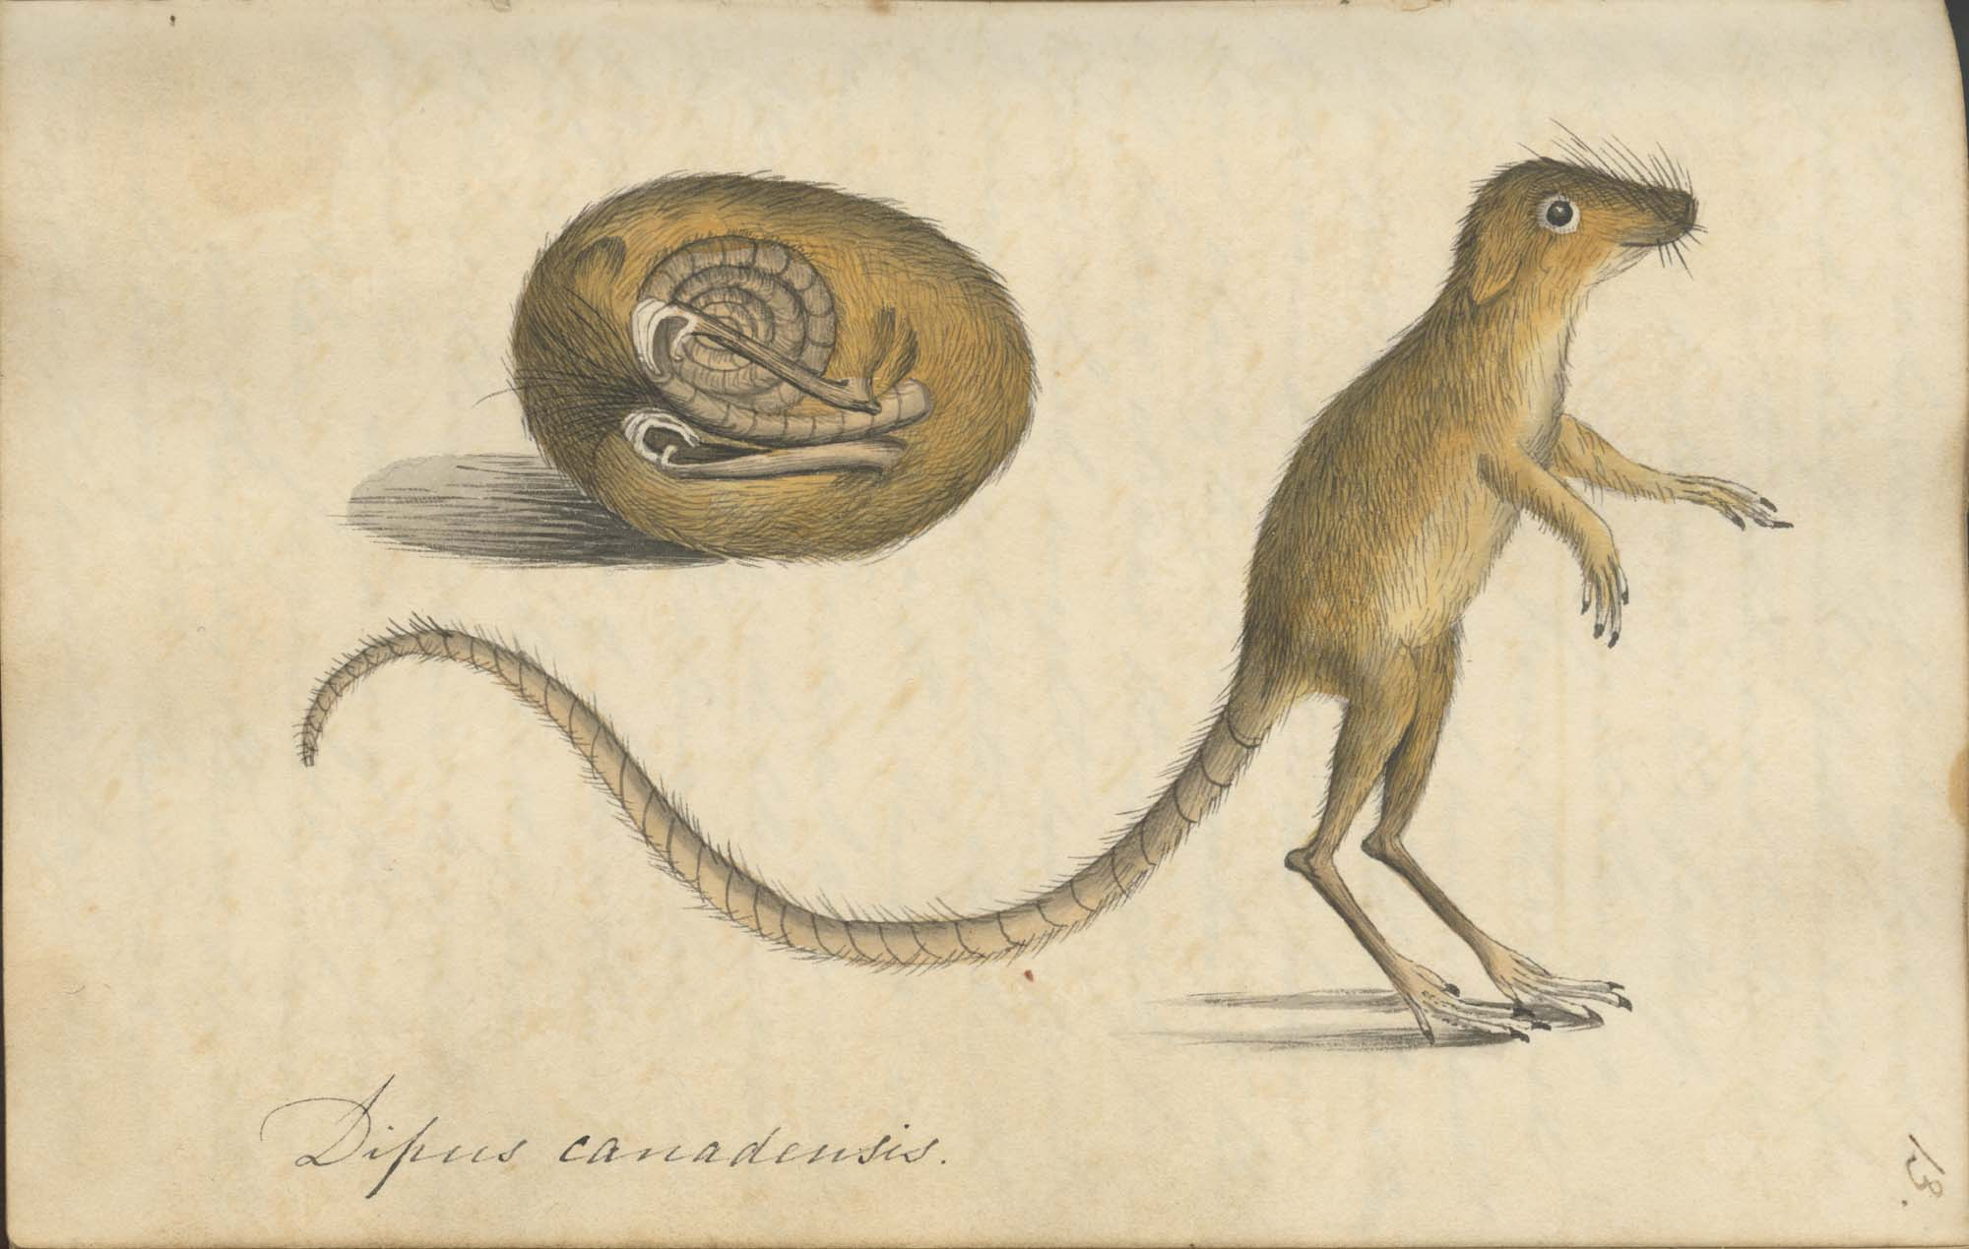

Notes to editors
High resolution images and caption/credit info can be downloaded here.
Further information and images please contact:
Danielle Czerkaszyn
Librarian and Archivist
Oxford University Museum of Natural History
danielle.czerkaszyn@oum.ox.ac.uk

About Oxford University Museum of Natural History

Founded in 1860 as the centre for scientific study at the University of Oxford, the Museum of Natural History now holds the University’s internationally significant collections of entomological, geological and zoological specimens. Housed in a stunning Pre-Raphaelite-inspired example of neo-Gothic architecture, the Museum’s growing collections underpin a broad programme of natural environment research, teaching and public engagement.

www.oumnh.ox.ac.uk
www.morethanadodo.com

About the National Heritage Memorial Fund

The National Heritage Memorial Fund (NHMF) was set up in 1980 to save the most outstanding parts of our national heritage, in memory of those who have given their lives for the UK.

Oxford University Museum of Natural History received a grant of £224,450 to support the Buckland Archive acquisition.

www.nhmf.org.uk
@NationalHeritageMemorialFund
#NationalHeritageMemorialFund

About the Arts Council England/V&A Purchase Grant Fund
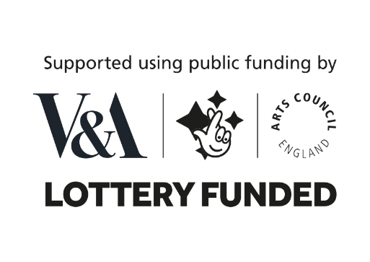
The Arts Council England/V&A Purchase Grant Fund is a government fund that helps regional museums, record offices and specialist libraries in England and Wales to acquire objects relating to the arts, literature and history. It was established at the Victoria and Albert Museum (V&A) in 1881 and continues to be part of its nationwide work.

The annual grants budget, currently £725,000, is provided by Arts Council England National Lottery Funding Each year. The Purchase Grant Fund considers some 150 applications and awards grants to around 100 organisations, enabling acquisitions of over £3 million to go ahead.

Oxford University Museum of Natural History received a grant of £50,000 to support the Buckland Archive acquisition.

www.vam.ac.uk/purchasegrantfund

About Friends of the National Libraries

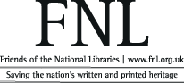

Friends of the National Libraries (FNL) has helped to save the nation’s written and printed history since its foundation in 1931. FNL awards grants to national, regional and specialist collecting libraries enabling them to acquire rare books, manuscripts, literary archives, fine bindings and estate archives that would otherwise be lost to the public domain and, in very many cases, to the nation.

Oxford University Museum of Natural History received a grant of £20,000 to support the Buckland Archive acquisition.
www.fnl.org.uk

