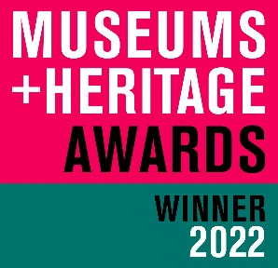
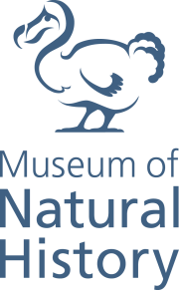
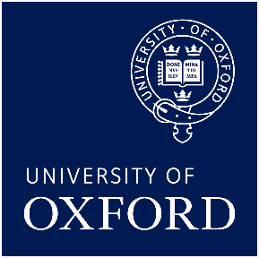

OUMNH WINS PRESTIGIOUS MUSEUMS + HERITAGE AWARD

The Museum of Natural History is delighted to announce that it has won a coveted Museums + Heritage Award in the Partnership of the Year category for the Meat the Future exhibition.

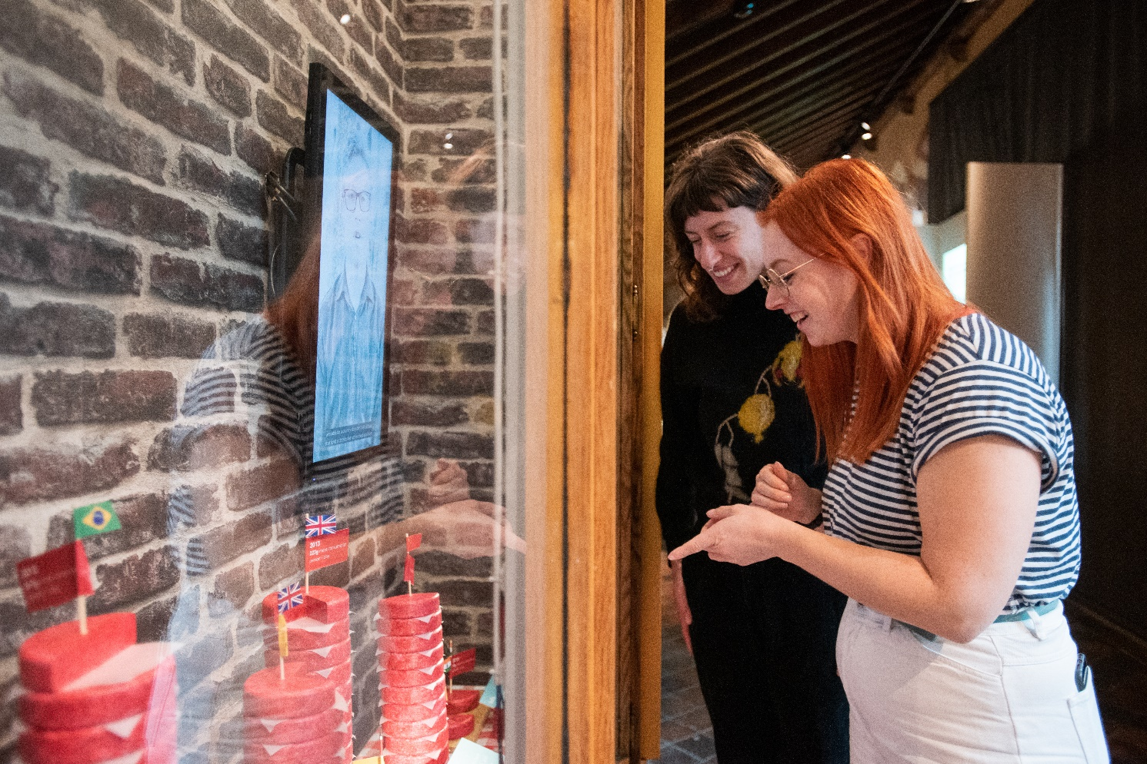
Meat the Future (now extended to run until 5 June), is a challenging exhibition examining how the production and consumption of meat affect people and the planet. Produced in partnership with Oxford University’s Livestock Environment and People (LEAP) research programme, the exhibition presents cutting edge research on the environmental and health impacts of eating meat, and offers new approaches to our diets, from simply eating less meat to adopting high-tech alternatives.
The Museum succeeded in a challenging awards category which included entries from Bristol Culture and Creative Industries (runner-up); the Roundhouse, Birmingham; the Natural History Museum, London; Science Museum Group; and the Jewish Museum, London.

Oxford University History of Science Museum was also among the 18 winning institutions, taking home the new award for Visitor Welcome.

For further information on the awards visit: https://awards.museumsandheritage.com/2022-winners/

To view the Online Exhibition: https://oumnh.web.ox.ac.uk/learn-meat-the-future

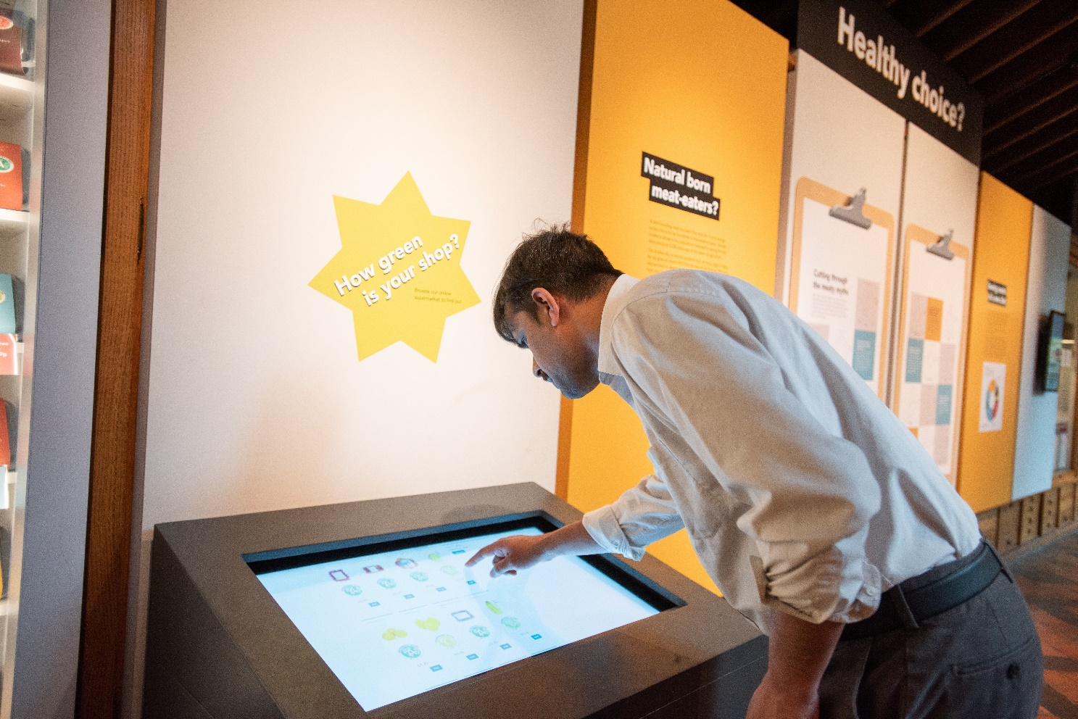
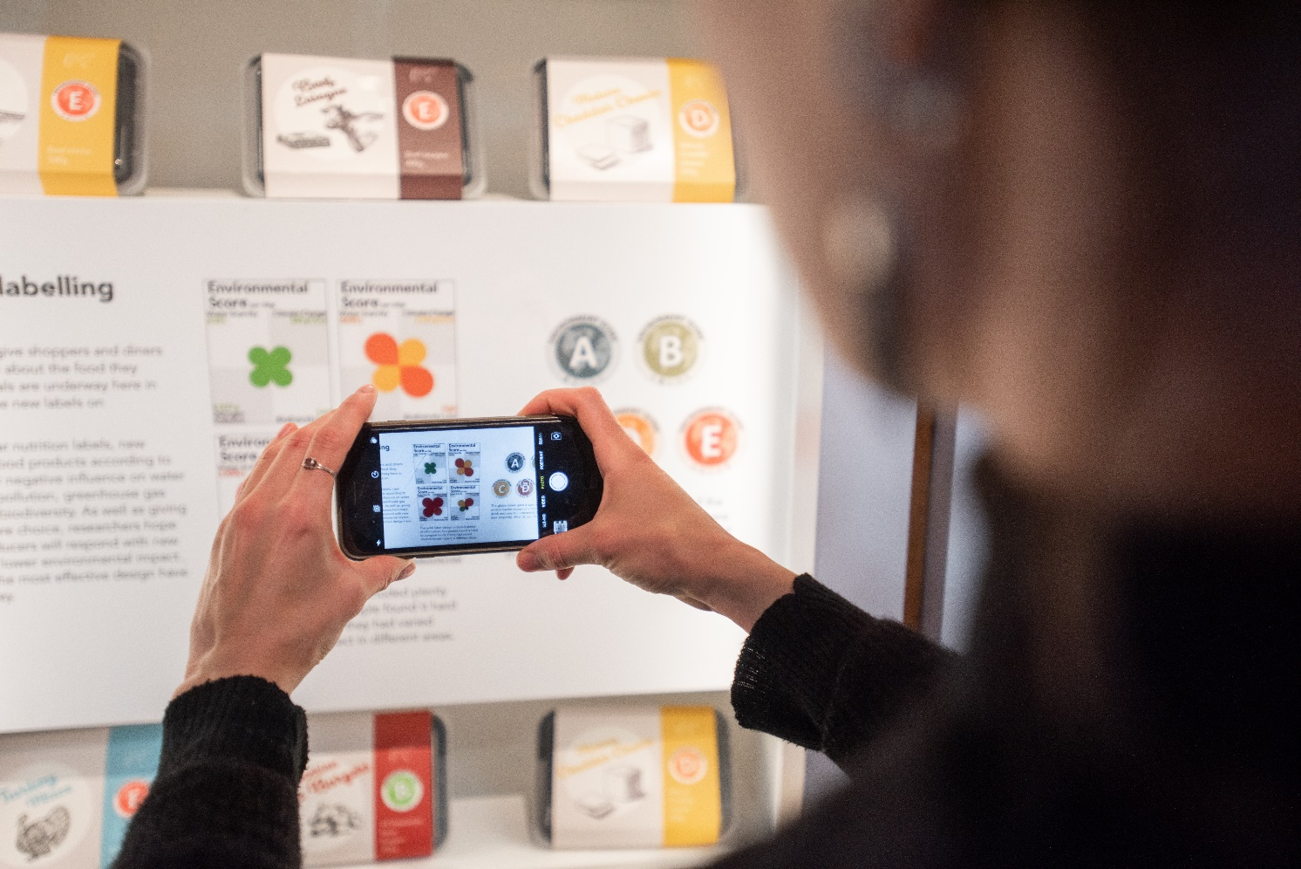

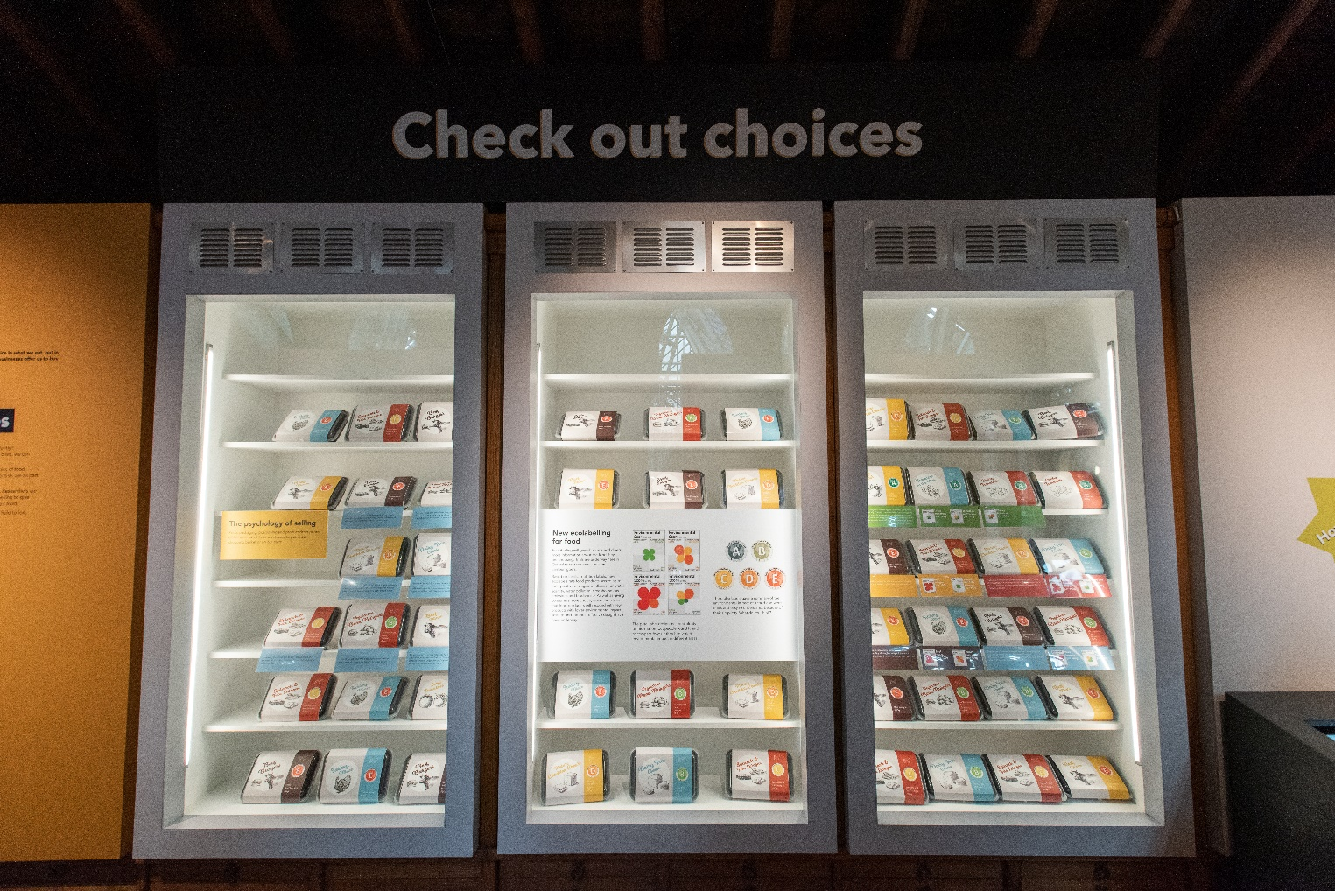

All Photography by John Cairns – please attribute

