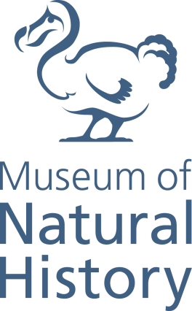

Conservator of Life Sciences

Grade 6: £28,660 - £34,189 p.a.

Full time (Part time, min 0.6 FTE, would be considered)

Permanent

The Museum of Natural History is looking for an experienced conservator to join the Life Collections team.

The historically important collections contain some of the earliest zoological specimens as well as modern research collections. The collections play an important part in our public engagement activities from objet based learning to displays. With a wide range of end users this proactive role forms and integral part of the museums mission. Based within a Grade I listed building the conservation issues are often challenging so a pragmatic creative approach is often required.

This permanent role will support the numerous storage initiates as we move forward to new off-site stores to house both wet and dry collections. The Museum is planning redevelopment of its permanent exhibitions and the conservator will perform a pivotal role in this decision making process.

The post requires a degree in the relevant field and a postgraduate qualification in museum conservation or equivalent experience
Applicants must complete the online application form on Oxford University’s website and include a CV and supporting statement addressing the selection criteria as listed in the Job Description. The supporting statement must explain how you meet each of the selection criteria for the post, using examples of your skills and experience. This may include experience gained in employment, education, or during career breaks (such as time out to care for dependants).
For further details on the Museum please see our website www.oumnh.ox.ac.uk. Please contact the Head of Digital and Print Collections using the contact details below.
Closing date: Friday 1st February noon 2019
Interview date: Tuesday 12th February 2019
Contact: Darren Mann – Darren.mann@oum.ox.ac.uk

