Oxford University Museum of Natural History
Parks Road, Oxford, OX1 3PW

In collaboration with
British Entomological & Natural History Society (BENHS)
Biological Records Centre (BRC)

10.00 – Arrival tea / coffee / biscuits – Annexe

10.30 – Welcome & Housekeeping – Lecture Theatre

10.35 – Mark Gurney – Fear no weevil

10.55 – Jon Webb – Natural England update focusing on their work with DNA technology

11.15 – Katy Dainton– Beetle- eating beetles, and other forest pest biocontrol methods

11.35 – Jeff Blincow & Tim Newton - “If it doesn’t work, we won’t tell anyone we’ve started – a Saproxylic beetle project at Yardley Chase Training Area”

11.55 – Sue Townsend - FSC Field Studies Council: FSC Find Study Coleoptera

12.30 – 14.00 – Lunch (Museum café, local pub or bring your own - Annexe)

Hope Entomological Collections open 13.00 – 16.00
For collections use contact amoret.spooner@oum.ox.ac.uk

Hope Entomological Library open 12.30 – 16.00

Please contact Danielle Czerkaszyn library@oum.ox.ac.uk with your library requests in advance,
as there will not be a librarian working on the day to assist.

14.15
Helen Roy, Richard Lewington & Peter Brown – Ladybird field guide Q&A – Annexe

No booking needed, unless access is required for a specific collection/ archive.
THERE IS NO PUBLIC PARKING AT THE MUSEUM

For general enquiries please contact: amoret.spooner@oum.ox.ac.uk

Further Information: The Museum: http://www.oum.ox.ac.uk
BENHS: http://www.benhs.org.uk
The Biological Records Centre: http://www.brc.ac.uk
Travel: http://www.oxfordbus.co.uk
Parking: http://parkandride.oxfordbus.co.uk
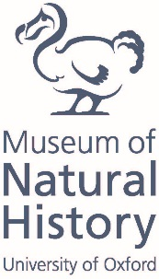
Accommodation: http://www.oxfordcityguide.com
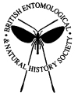
Diary date: 17th Coleopterists Day - 8 February 2020

